Homework 5-6

SCRUM CEREMONIES
- Product backlog refinement:The product backlog itself is a list of requirements/items to improve a product. The product backlog refinement is to add details to these requirements/items to improve the product therefore these requirements/items are ready for future Sprints
- Sprint planning: The purpose of sprint planning is to define which product backlog item the team will work and focus on during that sprint.
- Daily scrum: It is a 15-minute meeting each day of the Sprint where the team will review the progress since yesterday, define the activities for the day and adapt the Sprint Backlog if necessary
- Sprint review: The Sprint review is a meeting to show the outcome of the Sprint where the team gives a demo of the product, The team will show what is complete and what it isn’t complete
- Sprint retropective: The purpose of the Sprint is to review how the Sprint went and define what went well and what can be improved to increase the quality and effectiveness,

SCRUM ROLES
- ScrumMaster: The rôle of the Scrum Master is to lead a team through a project using Agile project management techniques and ensure that the agiles values/principles and processes are correctly followed,
- Product Owner: The product owner is responsible for the project’s outcome by maximizing the value of the product,
- Development Team: the team is a group of people that work together to create a working,validated product

Question 2

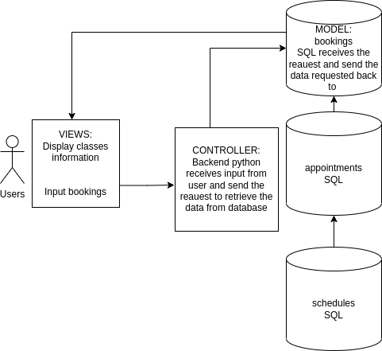

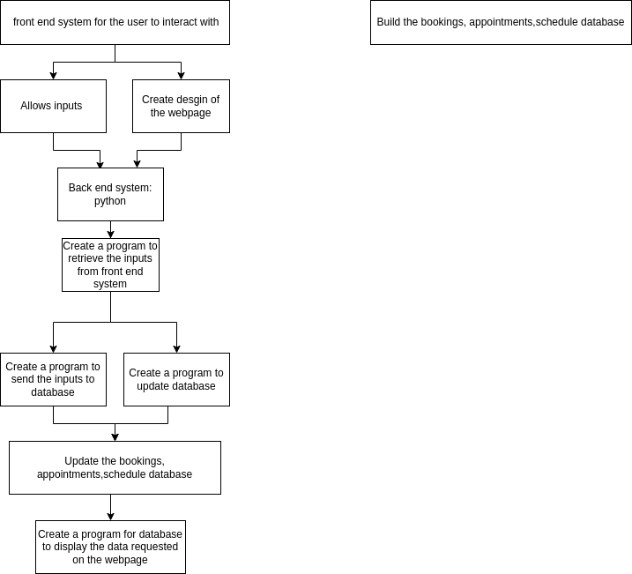

Question 3

Cinema booking system :
Key requirements :
- A database to record movies available at the cinema, Data required : date time,title, age rating, duration, trailer, synopsis, type of screening (2D,3D)
- A database for ticket cost. Data required : type of screening (2D, 3D) ,type of ticket(child/student/adult) and quantity
- A live database of seating availability in each room of the theatre for each movie seance
- A interface where user can look for the movies available at the cinema, Data required : date time, title, age rating, duration, trailer,synopsis, type of screening 2D, 3D) and cost
- A system to pick your seat in the room theatre ; (seats availabilty)
- A system to calculate the cost based on the quantity of ticket bought, Data required : (cost, quantity)
- A payment interface (CardNumber/CardType/ExpiryDate)
- A system to collect the ticket (Email address/DateTime/Title/Duration/Cost/room number)

Main considerations :
- User interface
- Database
- Link between User interface and database
- Payment system
- Ticket collection system

Main common problems :
- Interface user friendly for the customer
- Request and retrieve data from database
- Up to date database : movies are not staying for a long time at the cinema
- Up to date database : seating availability needs to be quickly update as there are several customers who can book for the same movie at the same time,

Main tools :
- SQL database to store the movies data
- SQL live up-to-date database for the seating availability
- Front end system(HTML/CSS/Javascript) for the interface the customer will interact with
- Back end system to link the SQL database to the front end system using python
- Calculator system using python

